1. A group of n 2 people decide to play an exciting game of Rock-Paper Scissors. As you may recall, Rock smashes Scissors, Scissors cuts Paper, and Paper covers Rock (despite Bart Simpson saying “Good old rock, nothing beats that!”). Usually, this game is played with 2 players, but it can be extended to more players as follows. If exactly 2 of the 3 choices appear when everyone reveals their choice, say a, b 2 {Rock, P aper, Scissors} where a beats b, the game is decisive: the players who chose a win, and the players who chose b lose. Otherwise, the game is indecisive and the players play again. For example, with 5 players, if one player picks Rock, two pick Scissors, and two pick Paper, the round is indecisive and they play again. But if 3 pick Rock and 2 pick Scissors, then the Rock players win and the Scissors players lose the game. 1 Assume that the n players independently and randomly choose between Rock, Scissors, and Paper, with equal probabilities. Let X, Y, Z be the number of players who pick Rock, Scissors, Paper, respectively in one game.   
   (a) Find the joint PMF of X, Y, Z.

**Ans : use the multinomial idea to obtain that the joint PMF is simply**

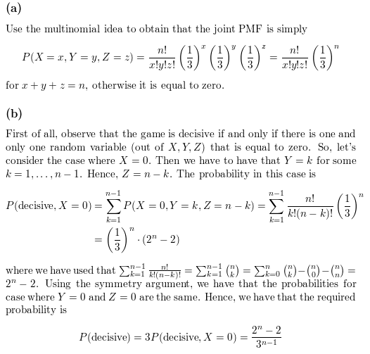

**For x + y + z = n, otherwise it is equal to zero**(b) Find the probability that the game is decisive. Simplify your answer (it should not involve a sum of many terms).

**Ans : observe that the game is decisive if and only if there is one and only one random variable (out of X, Y, Z) that is equal to zero. So, let’s consider the case where X = 0. Then we have to have that Y = k for some k = 1, … , n-1. Hence, Z = n – k. The probability in this case is**



**Where we have used that **

**2n – 2. Using symmetry argument, we have that the probabilities for case where Y = 0 and Z = 0 are the same. Hence, we have that the required probability is**

****(c) What is the probability that the game is decisive for n = 5? What is the limiting probability that a game is decisive as n ! 1? Explain briefly why your answer makes sense.

**Ans : from the part (b), plugging n = 5 we see thath the probability that the game is decisive is equal to (25 - 2) / (35 - 1) = 10/27. Now, we are interested what is happening with the probability when n 🡪 ∞**

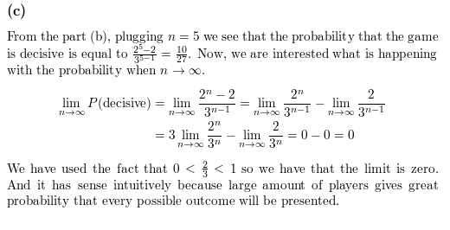

**We have used the fact that 0 < 2/3 < 1 so we have that the limit is zero. And it has sense intuitively because large amount of players gives great probability that every possible outcome will be presented.**